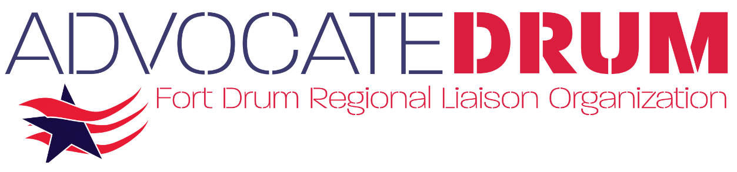

To protect and enhance Fort Drum’s military value, sustain, and leverage its economic and cultural significance
to the Fort Drum region and New York State, and foster effective communication between the installation and its civilian neighbors to promote mutual support and understanding.

Planned

- Fort Drum Steering Council formed in 1985, funded by Office of Economic Adjustment (OEA) and sponsoring local agencies.

- The Council helped build the North Country’s knowledge base regarding the Army’s decision to station the 10th Mountain Division at Fort Drum. This allowed community leaders, along with State and Local elected officials to understand the impact, be able to address community development plans and respond to the increased demands on local assets associated with the expansion and development on Fort Drum. Significant Community/Army decisions made during the early years of the Council:

      - Housing Community supported Section 801Housing, Tri-County, HUD financing
      - Healthcare Community hospitals supported growth; no hospital built on base
      - Education Community schools supported growth; no school built on base
- Infrastructure Community supported water, sewer, solid waste, and transportation

Positioned

- With the Steering Council sunset in 1990, the Fort Drum Regional Liaison Organization
(501(c) 4) was created to carry on the mission, as a volunteer, membership organization.

      - Membership includes 275+ businesses and individuals from Tri-County and CNY area.
      - Board of Directors (25) comprised of community leaders from diverse professional fields, representing Fort Drum, Jefferson, Lewis, and St. Lawrence counties.
      - FDRLO operating committees (8) consist of Board Members and Community Partners.
      - Annually develop Fort Drum Regional Economic Impact Report; direct, indirect and induced
      - Executive Directors have served on the North Country Regional Economic Development Council, Watertown-Jefferson County Area Transportation Council Committees, Jefferson County Comprehensive Economic Development Strategy (CEDS) Committee, and Fort Drum Joint Land Use Study Steering Committee, Technical Working Group and Compatibility Committee.
      - Annual Budget $250,000+, Membership dues and Counties’ support $95,000

Proven

- Serves as the voice for the Fort Drum region and an advocate for Fort Drum to protect it from threats of BRAC or troop reductions. Promotes the installation for additional missions and works with Community and Installation on initiatives that enhance Fort Drum’s Military Value.

      - 1988, Base Realignment and Closure (BRAC)
      - 1991, Base Realignment and Closure (BRAC)
      - 1993, Base Realignment and Closure (BRAC)
      - 1995, Base Realignment and Closure (BRAC)
      - 2003, FDRLO constituted a Housing Task Force; Residential Communities Initiative (RCI)
      - 2004, Facilitated community investments to increased demands (housing, education & healthcare) associated with stationing the 3rd Brigade Combat Team at Fort Drum.
      - 2004, Assisted in highlighting need and securing NYS funding for Interstate I-781
      - 2005, Partnered with JCEDC to secure NYS funding of Fort Drum Railhead Siding
      - 2005, Assisted in the creation of the Fort Drum Regional Health Planning Organization
      - 2005, Base Realignment and Closure (BRAC)
      - 2007, Partnered with the Tug Hill Commission and Tug Hill Tomorrow Land Trust in securing NYS matching funds for the Army Compatible Use Buffer program.
      - 2008, Created ‘Drum Country Business’ a regional marketing initiative, among FDRLO, the Industrial Development Agencies of Jefferson, Lewis and St. Lawrence Counties, Development Authority of the North Country, and National Grid.
      - 2009, Established Growth Management Task Force and developed Fort Drum Growth Management Strategy; provided training for local planning and zoning officials.
      - 2011, Launched Public Transportation and Mobility study
      - 2013, Led community response to Programmatic Environmental Assessment, Army 2020 Force Structure Realignment
      - 2014, Facilitated New York State adopting the Interstate Compact on Educational Opportunity for Military Children
      - 2015, Led Federal, State, and regional community response to Supplemental Programmatic Environmental Assessment, Army 2020 Force Structure Realignment; Army proposed Fort Drum job cuts: 16,000; actual job cuts at Fort Drum: 28.
      - 2016, Facilitated and secured funding for NYS Route 26 Intersection at Fort Drum and Bomporto Bridge connecting the main cantonment to Wheeler-Sack Army Airfield
      - 2016, Led regional campaign to secure Fort Drum as the preferred site for future East Coast Missile Defense Project
      - 2018, Rebranded FDRLO as Advocate Drum to better reflect who we are and what we do
      - 2018, FDRLO Education Survey, validate and measure the high-quality education provided for military and civilian children
      - 2019, North Country receives Great American Defense Community Award
      - 2019, Partnered with Fort Drum Transition Services, and JCED to provide employer tours at Fort Drum, see Soldier skills first-hand
      - 2020, NYS Final Approval of the Transitional J Certificate for Teachers
      - 2020, Assisted in securing OLDCC DCIP Grant for the Watertown YMCA Community & Aquatic Center.
      - 2021, Interview & Insights – Speaker Series
      - 2022, Led regional campaign to secure Fort Drum as the preferred site for a Multi-Domain Task Force.
      - 2023, Organized and carried out Army Career Day event at Fort Drum for tri-county school districts.

